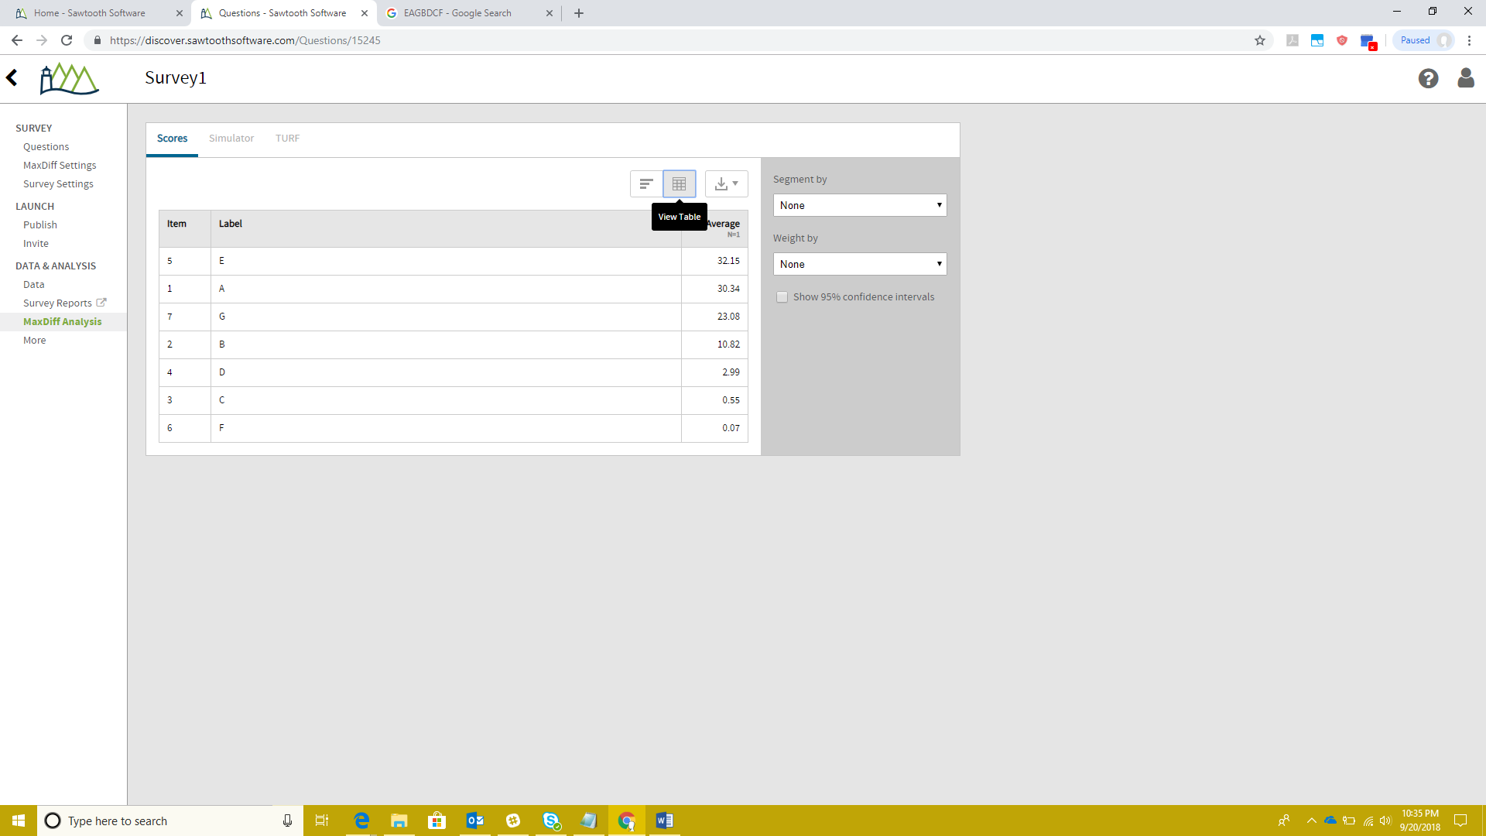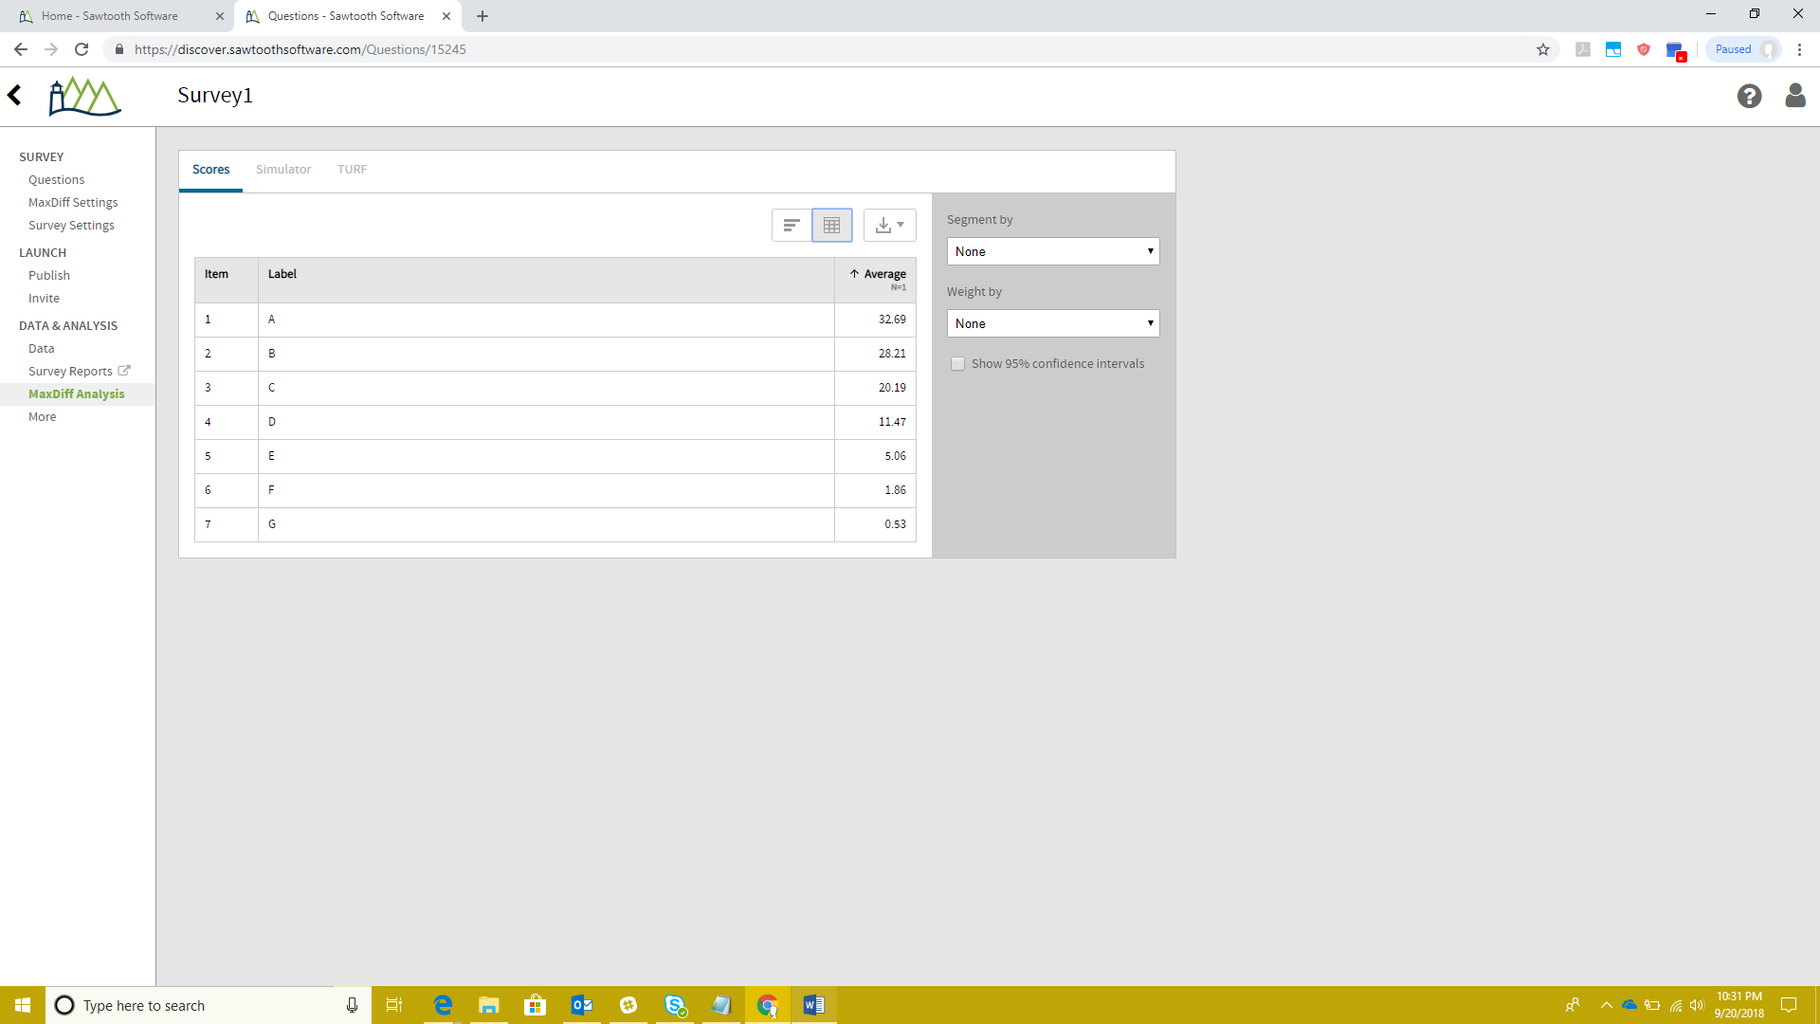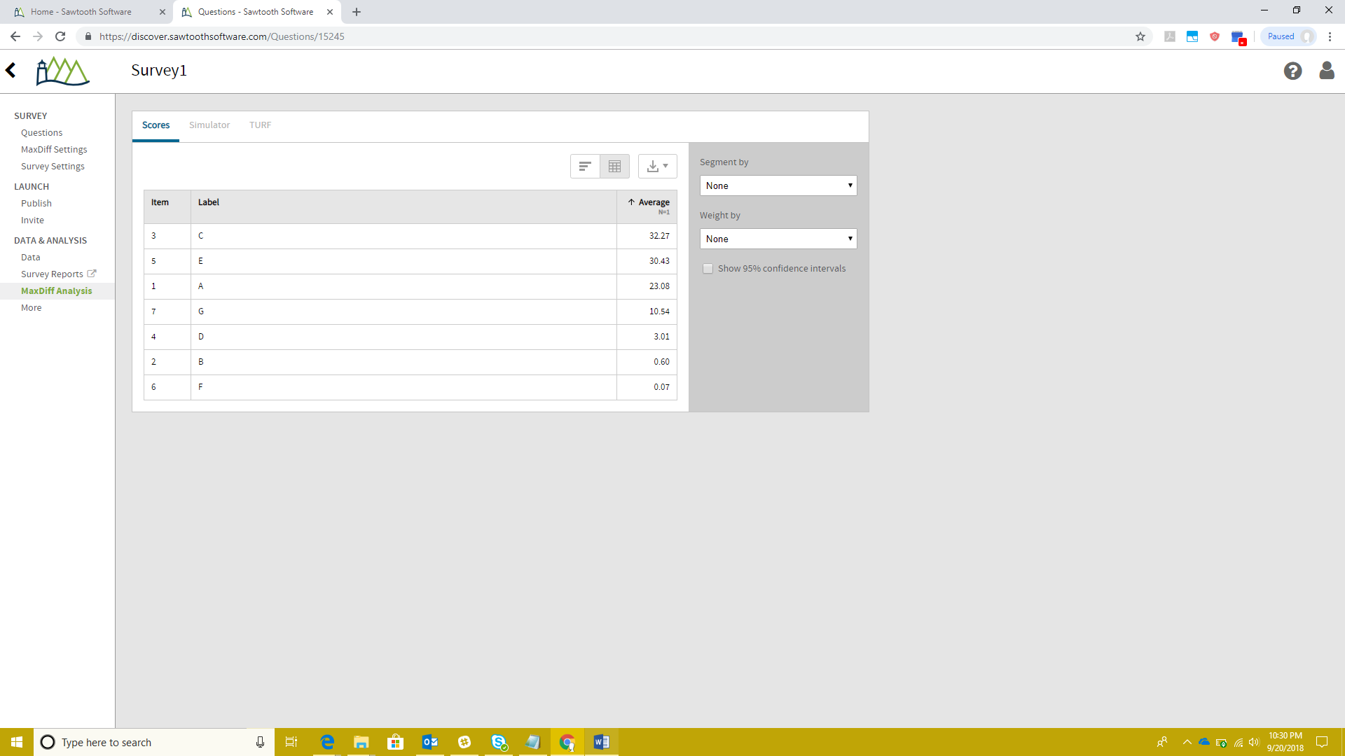

G>E>A, C>F>A, F>E>D, B>D>A, D>C>G, C>B>E, B>G>F

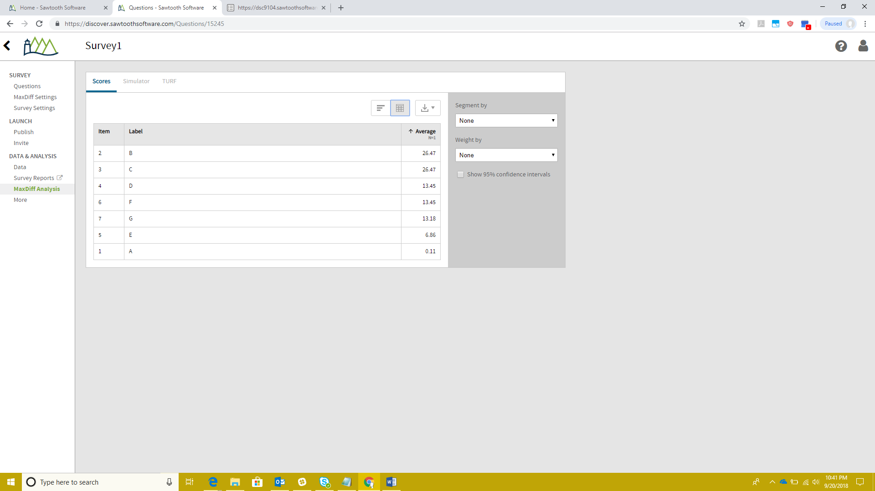

C>A>H, F>G>A, H>E>B, E>A>D, G>B>C, D>B>F, C>E>F, D>H>G

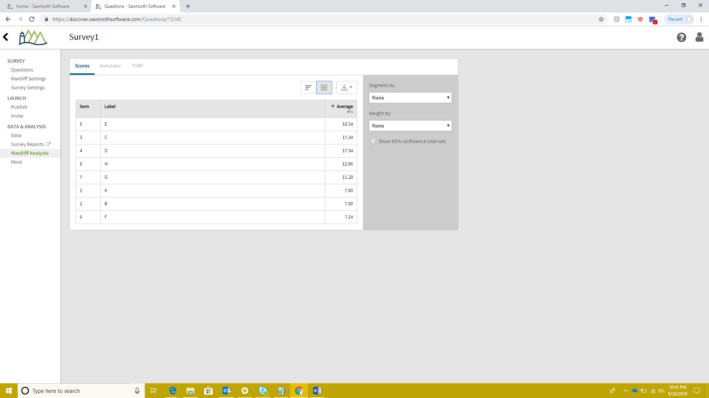

A>B>C>D>E>F>G>H>I

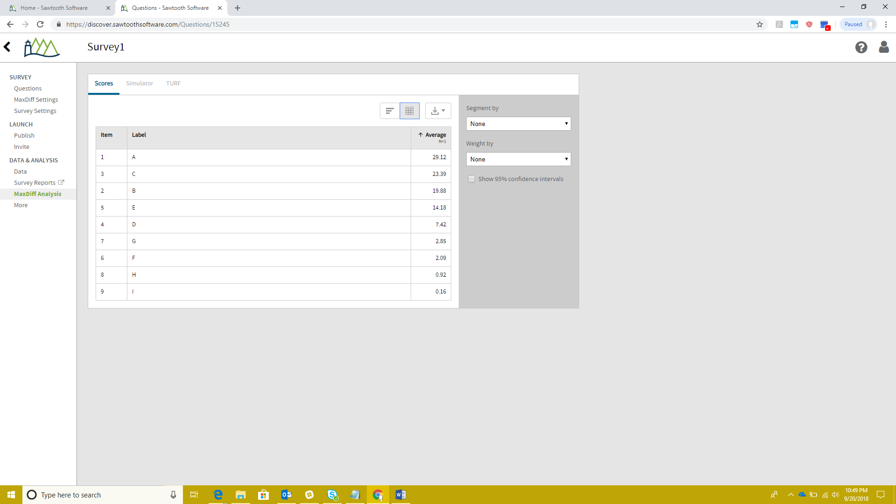

16 attributes, recommend 5 per question, used 4

F>H=I>J, O>G=N>P, B>D=K>L, M>C=A>E, B>E=J>O, I>C=P>D, K>G=F>A, L>N=H>M, C>B=F>N, A>P=L>J, G>E=H>D, I>O=M>K

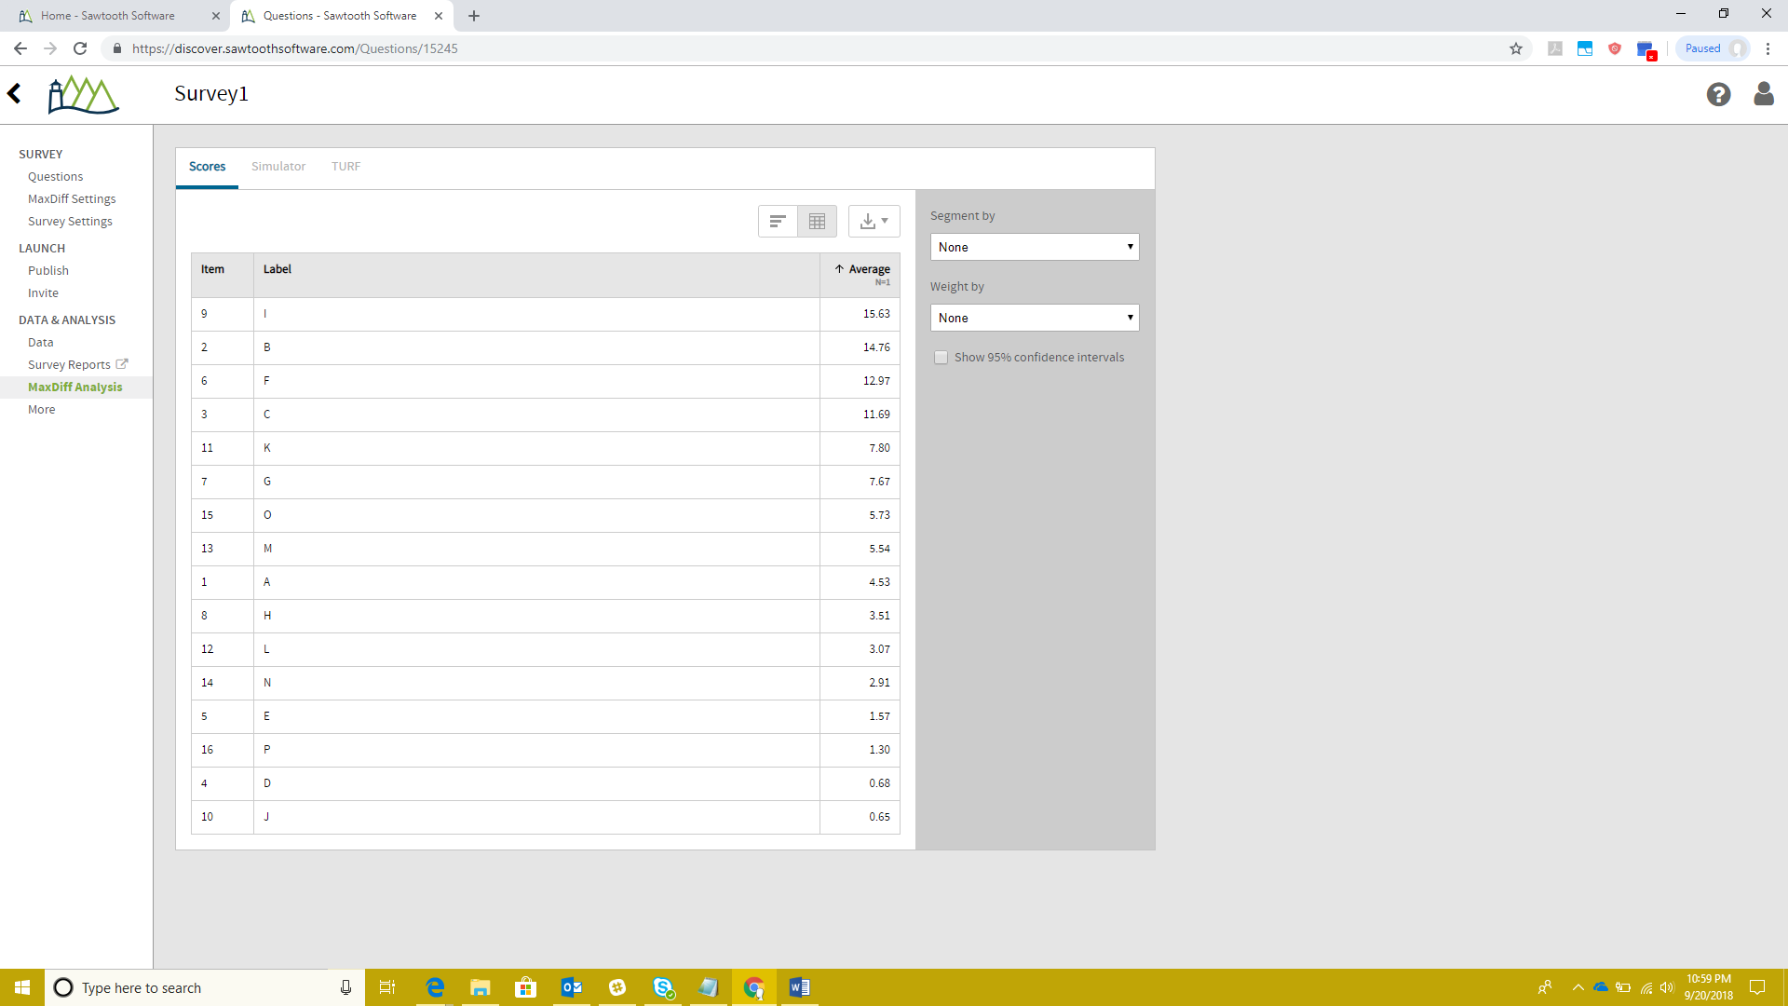

17 attributes 5 attributes per question

A>B>C>D>E>F>G>H>I>J>K>L>M>N>O>P>Q

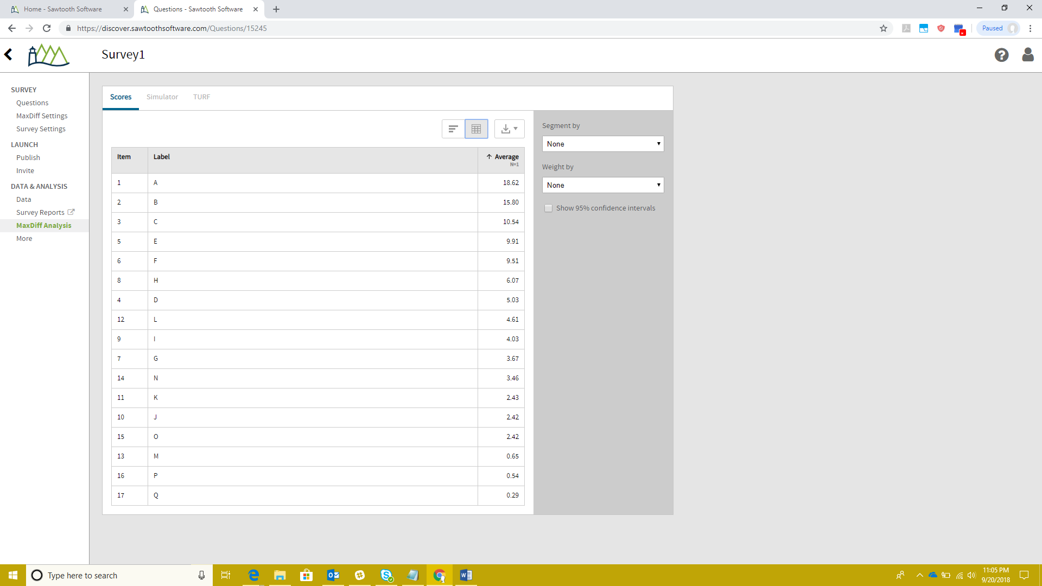

17 attributes 4 attributes per question

A>B>C>D>E>F>G>H>I>J>K>L>M>N>O>P>Q

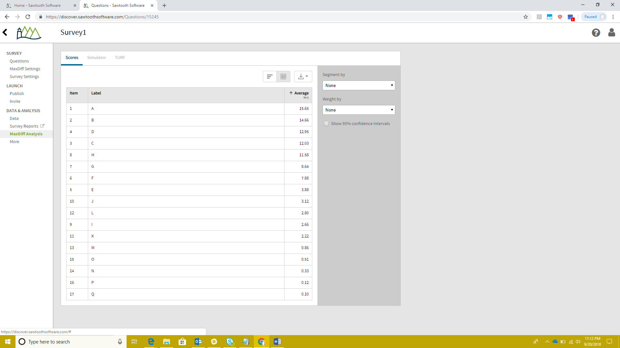

17->11 attributes = 5 per question

10->9 attributes = 4 per question

8->5 = 3 per question